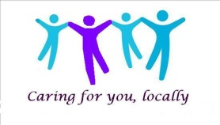
Crosland Moor Surgery

Patient Participation Group (PPG) Guidance

- This meeting is not a forum for individual complaints and single issues.

- We advocate open and honest communication and challenge between individuals.

- We will be flexible, listen, ask for help and support each other.

- We will demonstrate a commitment to delivering results, as a group.

- Silence indicates agreement – speak up, but always go through the chair.

- All views are valid and will be listened to.

- No phones or other disruptions at meetings.

- We will start and finish within the timeframe set and stick to the agenda.

